Math Worksheet #3.1
- (12-4ex2) Multiply: 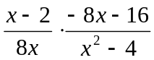
- (12-5ex1) Divide: 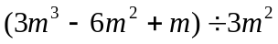
- (12-7ex2) Solve: 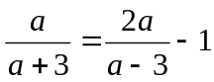
- (11-7) Find x to the nearest hundredth

y
20º
10
x
Math Worksheet #3.2
- (12-4ex3) Multiply: 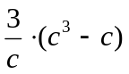
- (12-6ex3) Add: 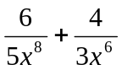
- (12-7ex2) Solve: 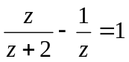
- (11-7) Find x to the nearest hundredth

x
20º
y
10
Math Worksheet #3.3
- (12-4ex4) Divide: 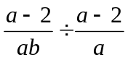
- (12-6ex3) Add: 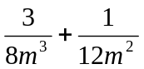
- (12-7ex5) Solve: 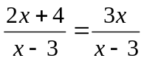
- (11-7) Find x to the nearest hundredth

x
20º
15
y
Math Worksheet #3.4
- (12-3ex3) Simplify: 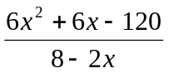
- (12-4ex5) Divide: 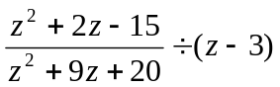
- (12-6ex4) Add: 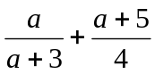
- (12-7ex5) Solve: 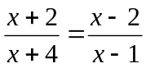
- (10-7ex1) Solve: 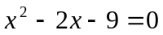
Math Worksheet #3.5
- (12-3ex3) Simplify: 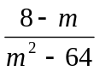
- (12-5ex3+4) Divide: 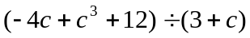
- (12-6ex4) Add: 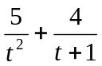
- (12-7ex5) Solve: 